**Implement Programs For Time Series Data Cleaning, Loading, And Handling Time Series Data And Pre-Processing Techniques**

**EX.No:1 DATE: 25/01/2**

**AIM:**

To clean, preprocess, and visualize electricity production data, focusing on trend analysis and handling missing values.

**ALGORITHM:**

1. Load the electricity production data from the CSV file.
2. Parse the date column and set it as the index.
3. Handle missing values by filling them with forward fill.
4. Convert numerical columns (e.g., production values) to appropriate data types.
5. Compute moving averages (7-day and 30-day) for trend analysis.
6. Drop any rows with NaN values created during moving average computation.
7. Visualize the electricity production values along with the moving averages using a line plot.

**CODE:**

import pandas as pd

import matplotlib.pyplot as plt

file_path = "C:\\Users\\Lenovo\\Downloads\\Electric_Production.csv"

df = pd.read_csv(file_path)

print("Initial Data Info:")

print(df.info())

print("\nMissing Values Before Handling:\n", df.isnull().sum())

df = df.dropna()

df = df.drop_duplicates()

df[df.columns[0]] = pd.to_datetime(df[df.columns[0]], errors='coerce')

df = df.dropna(subset=[df.columns[0]])

df = df.sort_values(by=df.columns[0])

df = df.reset_index(drop=True)

print("\nData Info After Processing:")

print(df.info())

plt.figure(figsize=(12, 6))

plt.plot(df[df.columns[0]], df[df.columns[1]], label='Electric Production', color='b')

plt.xlabel('Date')

plt.ylabel('Production')

plt.title('Electric Production Over Time')

plt.legend()

plt.grid(True)

plt.show()

**OUTPUT:**

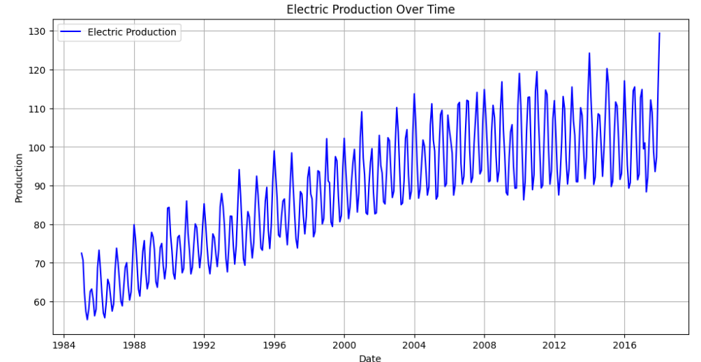

**RESULT:**

Thus the program has been completed and verified successfully.